**Learning Outcomes**

* Understanding Auto-complete Text view, Edit Text, Scroll View
* Understanding Checkbox and Radio-button

**EditText**

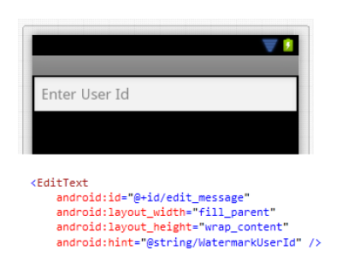

**EditText as Password Box**

By setting InputType as textPassword, the EditText control will behave as password box.

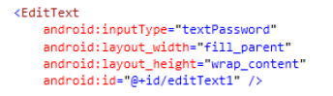

**Multiline EditText**

By setting the InputType as textMultiLine would enable the multiline in EditText.

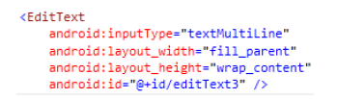

**ScrollView**

ScrollView is a control which enables its content to scroll if its width or height extends beyond the screen width and height.

In the layout below, a ScrollView is added before the LinearLayout-Vertical with many buttons in it. And at runtime the main LinearLayout becomes scrollable.



**Scrollable TextView**

Make changes to the TextView like the following and this should do the trick.



**Auto-complete text view**

**Start a new Project**

This is another input type controls. This is similar to EditText control, except that; it has a collection from which it would give you suggestion once you start typing. The minimum length for typing is 2.

First of all we create a resource array. Resource arrays are defined in **Strings.xml**.

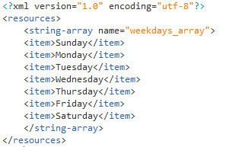

Layout

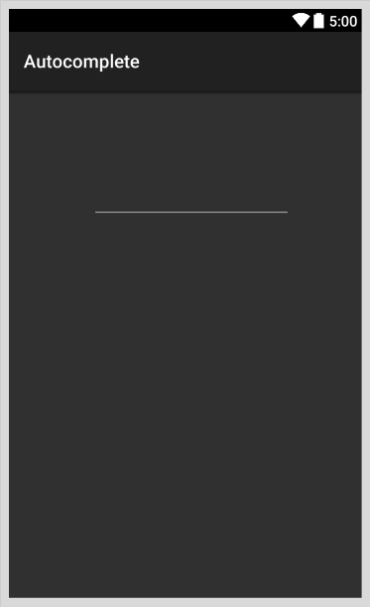

**Code**

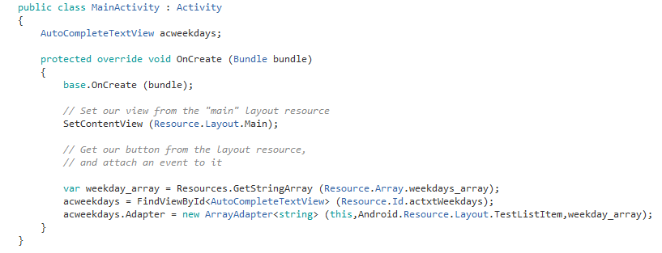

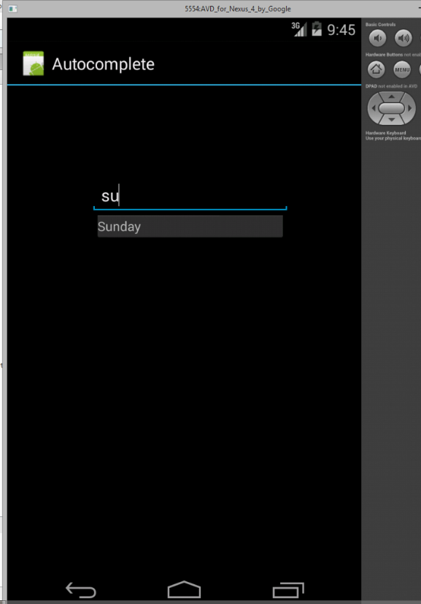

**Using an array inside the code**

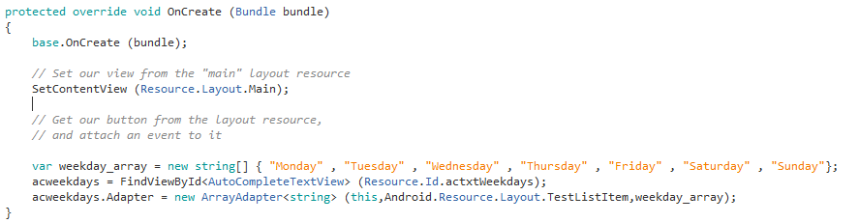

**Checkbox and Radio Button**

Design a layout with checkboxes in it

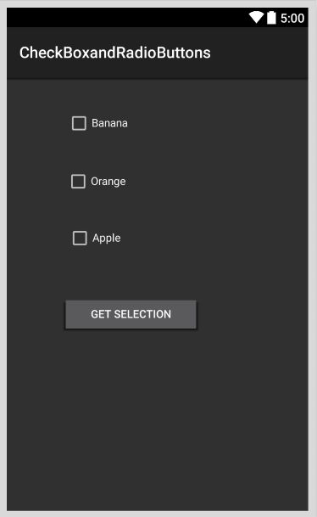

Declare your Checkboxes and Buttons

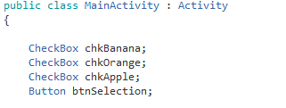

Initialize the controls and attach click even to it

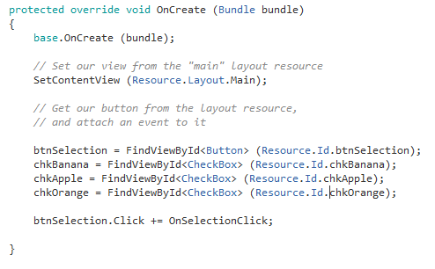

Show toast messages on click of the Button

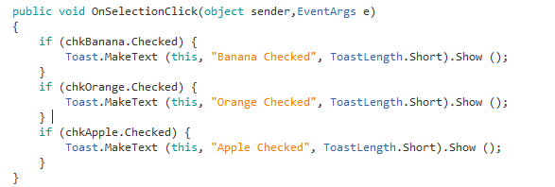

**Radio-Button**

To add radio-buttons first we need to group them together using a radio group control

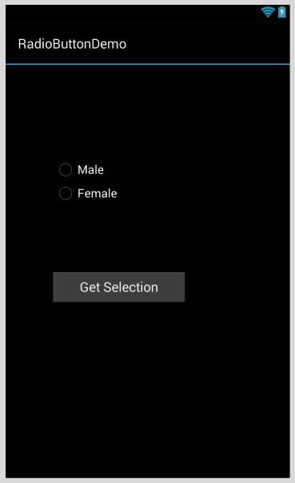

Radio group

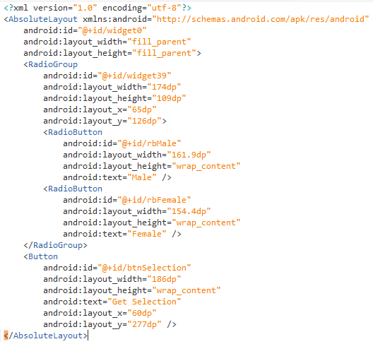

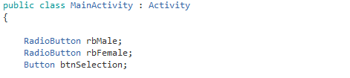

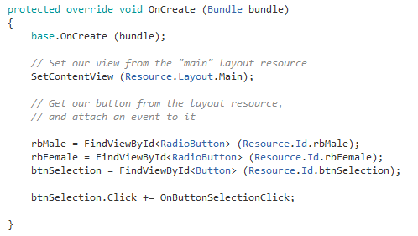

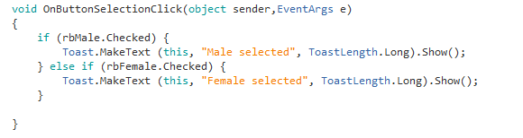

**Exercise**

1. Implement an App to read a text file from the assets folder and show it in a scrollable TextView.

(Hint – Google search Query -> Reading a text file in Xamarin Android)

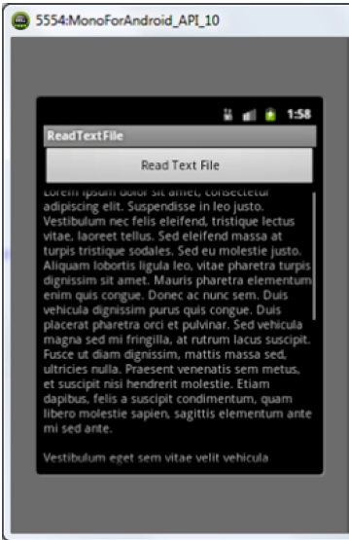

1. Implement the Temperature Converter app

